***EXPERIMENT NO. 3***

***OBJECTIVES:***

**RC Circuit:**

1) To observe and trace the complete response to step input. 2) To determine the time constant and check with the theoretically calculated value.

**RLC Circuit:**

1) Adjust the parameters so that an underdamped response of the series RLC circuit is obtained and to observe and trace of the response.

2) From the trace response, obtain the period of oscillation, settling time, peak overshoot, rise time, peak time, delay time and compare these values theoretically calculated values.

3) To adjust the parameter values so that a critical response of the series RLC circuit is obtained.

4) To compare the critical resistance with the theoretical value.

***PROCEDURE:* Part – I (RC Circuit):**

1) Connect the circuit and observe and trace or record (wherever possible) the waveforms appearing on the CRO screen. RC Circuit:

* Frequency=200-500Hz (square wave)

* C=0.22µF

* R=470Ω

2) From the trace find the time constant and compare with the theoretical value.

3) Find the equation for the total response of the circuit.

Circuit Diagram:

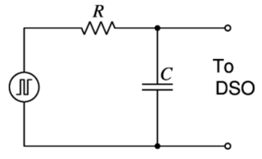

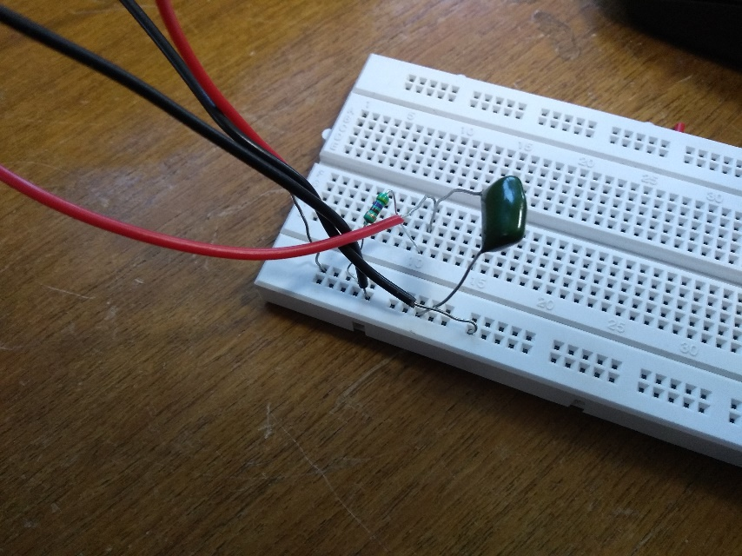

Snapshot of the breadboard with the circuit connected as in circuit diagram

Snapshots of the DSO screen:

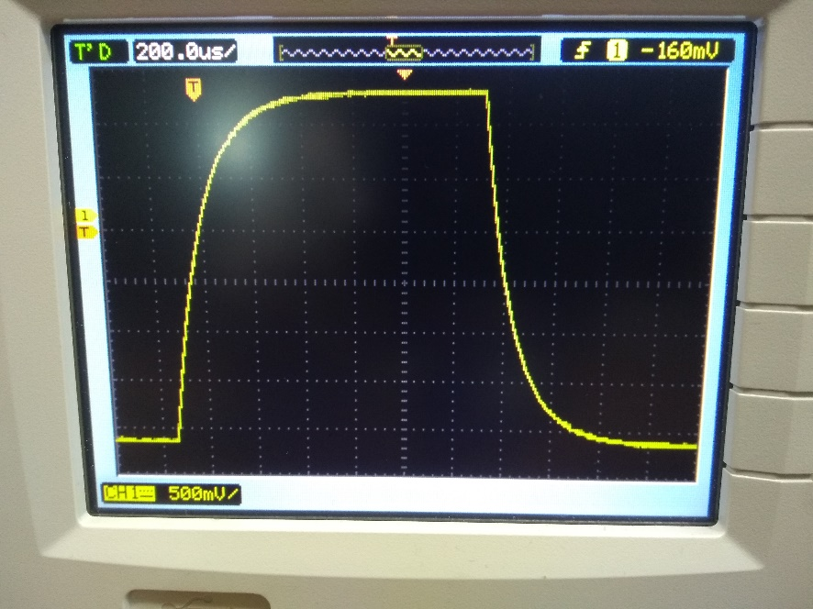

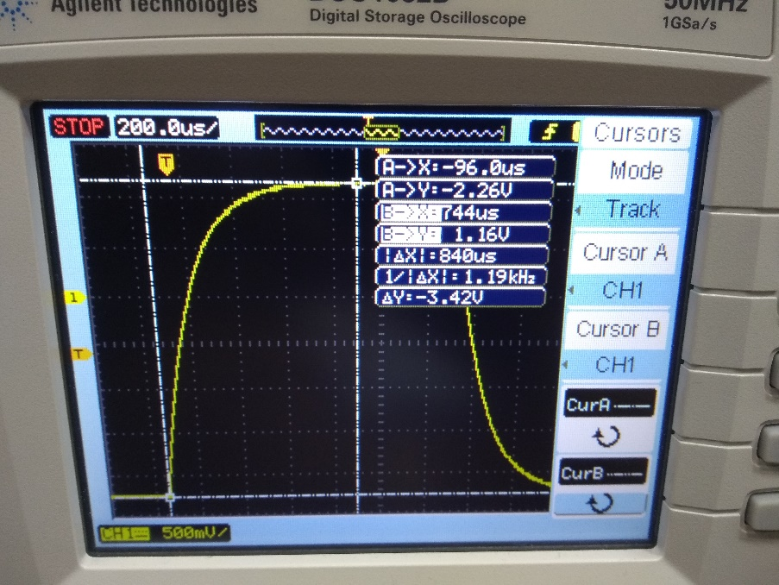

Observations:

|  |  |  |  |  |  |
| --- | --- | --- | --- | --- | --- |
| **V0 (V)** | **0.63 V0** | **time const (µs)** | **Freq (Hz)** | **0.37 V0** | **time const (µs)** |
| 3.42 | 2.1546 | 132 | 400 | 1.2654 | 130 |
| 4.04 | 2.5452 | 130 | 200 | 1.4948 | 130 |
| 4 | 2.52 | 135 | 300 | 1.48 | 125 |

**Part – II (RLC Circuit):** 1) Connect the circuit (Square wave as Input) and observe and trace or record (wherever possible) the waveforms appearing on the CRO screen.

2) Adjust the values of the resistance to obtain responses corresponding to underdamped, critically damped and overdamped cases.

3) Underdamped Frequency = 20Hz ; R = 470Ω 4) Critically damped Frequency = 20Hz; R = 5kΩ 5) Over-damped Frequency = 20Hz; R = 9.88kΩ

6) Mostly underdamped systems are preferred due to moderate time domain specifications. Calculate all the time domain specifications and verify them theoretically.

7) Calculate the critical value of resistance(the resistance at which system becomes critically damped)

Circuit Diagram:

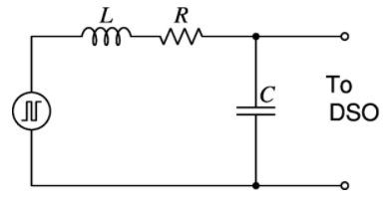

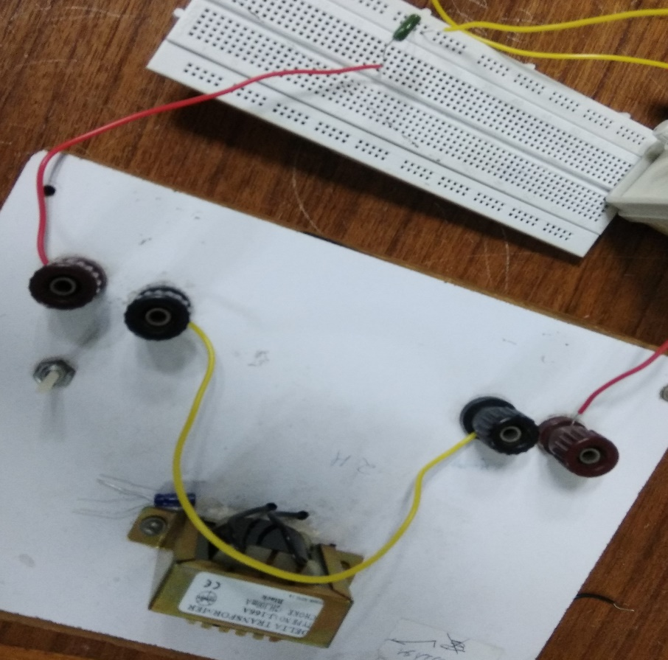

Snapshot of the breadboard with components connected as per the circuit diagram

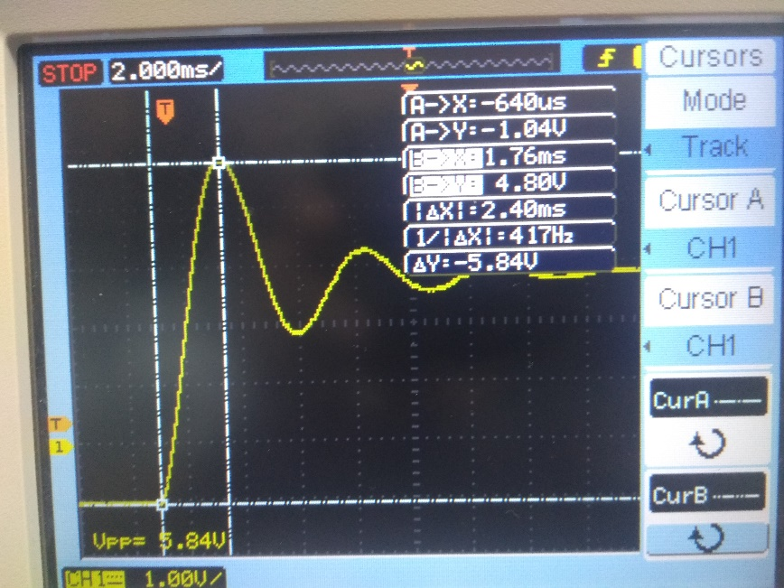

Underdamped case

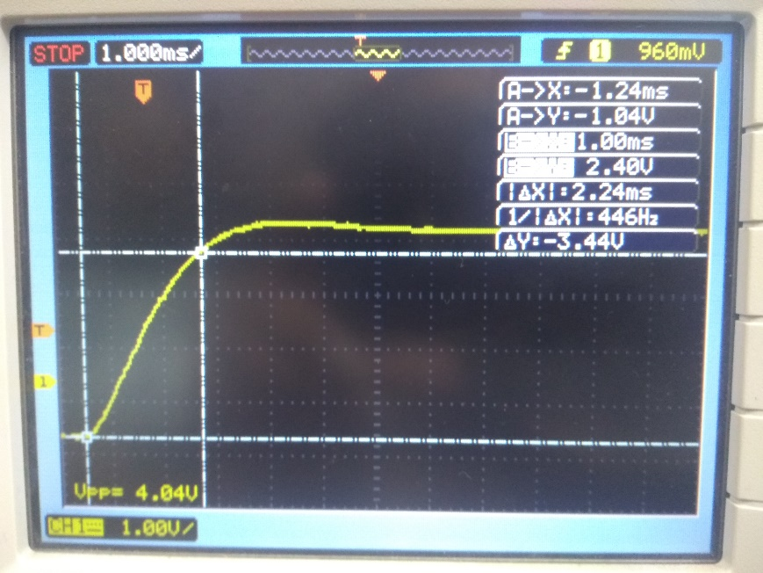

Critically Damped case

(We forgot to take the snapshot of the overdamped case)

Observations:

|  |  |  |  |
| --- | --- | --- | --- |
|  | **Underdamped** | **Critically damped** | **Overdamped** |
| **Peak** | 5.84 V | 4 V | 3.84 V |
| **Mp** | 2 V | 0.16 V | N.A. |
| **Tp** | 2.40 ms | 3.96 ms | 2.84 ms |
| **Td** | 0.77 ms | 1.12 ms | 1.92 ms |
| **Tf** | 1.2 ms | 2.26 ms | 5.08 ms |
| **Ts** | 8.0 ms | 2.26 ms | 5.08 ms |

**PRECAUTIONS:**

1) The square waveform from the function generator or pulse generator may be checked on DSO and adjust to the proper size before applying it to the circuit. The time scale on DSO must also be calculated.

2) Once the proper square wave is synchronized on DSO and the time scale is calibrated, the setting of the knobs affecting the calibrated should not be changed.

3) In the RLC Circuit response care should be taken to include the resistance of the inductor used in the circuit while making various calculations.

**Error Analysis:**

During the whole experiment, I encountered few places where there was a possibility of errors. First of all, there may be a chance that the actual voltage received in the circuit will be lesser than the voltage applied due to some loss. And it may give somewhat different results. Moreover, it should be ensured that all connections in the circuit are correct. Often we face a fluctuated reading and in that situation, one must autoscale and then take a reading in the steady position. All these accounts for the error that may have crept in my experiment. The calculated value of time constant was 103.4 µs, but in charging condition, it came out to be 132 µs and 130 µs in discharging condition.

Coming to next part, the calculated values of Tf, Td, Tp, and Ts are 1.09ms, 699.5 µs, 2.11ms and 7.68ms respectively. The measured values are 1.2ms, 770 µs, 2.40ms, 8.0ms respectively. Moving forward we performed critical damping part where the critical damping occurred at R=5kΩ, but as suggested it should be around 4.26kΩ.

So, in a nutshell, I would like to wrap this error analysis by stressing on the fact that there is some small noticeable error in each measurement and as is the case, there is always some error associated with each experiment.

**Concluding Remarks:**

The experiment started with the measurement of the time constant of an RC circuit in the charging and discharging condition, and we verified the readings with the well-known result ꚍ=RC. Followed by this, we wrote the equation for total response of the circuit.

Then we connected an RLC circuit where we obtained different waveforms of underdamped, overdamped and critically damped by adjusting the values of R. In the underdamped condition we measured different time domain specifications (Td, Tr, Ts, Tp, etc.). Thereafter we verified the various time domain specification with their corresponding formulas. Overall this experiment made us familiar with the response of a circuit in the presence of some external source.